Constructing Parallel Line

Definition
# Source: AI Source: Provided by: [Data Path: Persons Table -> ID Column: 1, Name_En Column: Motasem Essam] -> From: [ChatGPT] on [7/25/2026]
Constructing a Parallel Line is the geometric construction of a line through a given point that is parallel to a given line.
Two lines are parallel when they lie in the same plane and never intersect, no matter how far they are extended.
If line $m$is parallel to line $l$:
$$\boxed{m∥l}$$
The main objective is to construct a line $m$through a given point $P$such that:
$$\boxed{P∈m \text{and} m∥l}$$
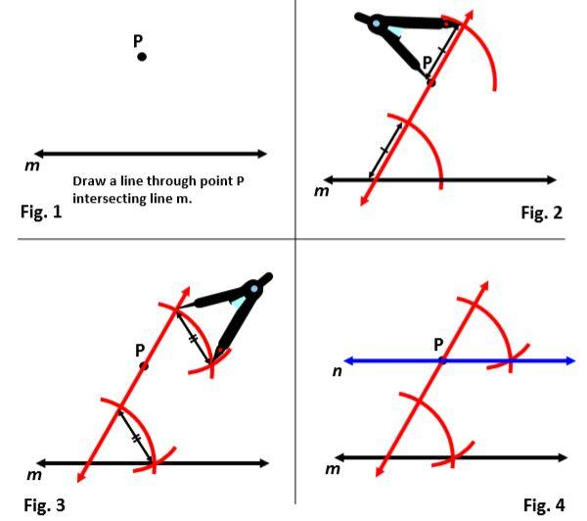
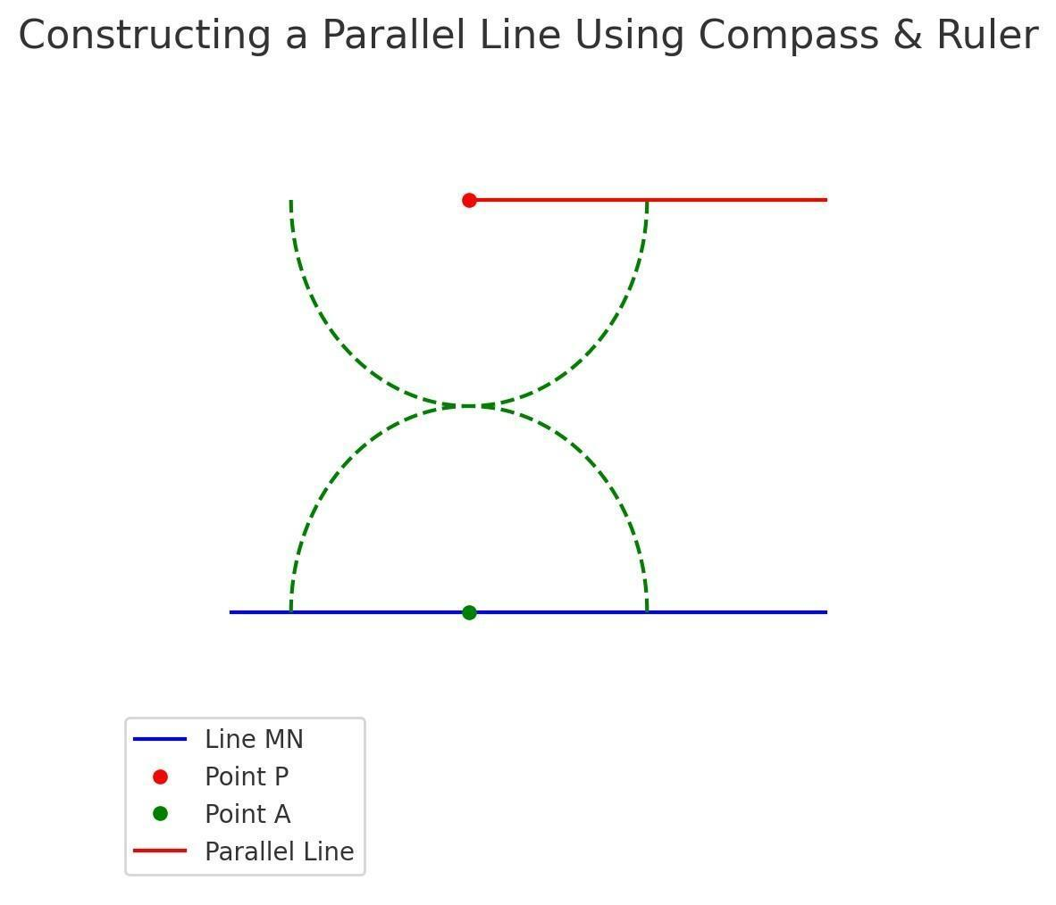
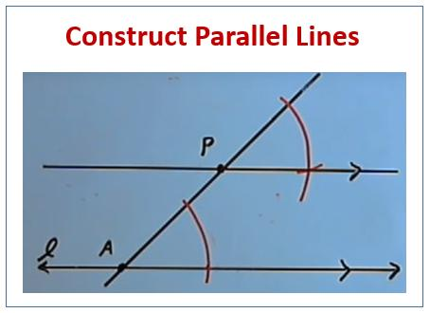
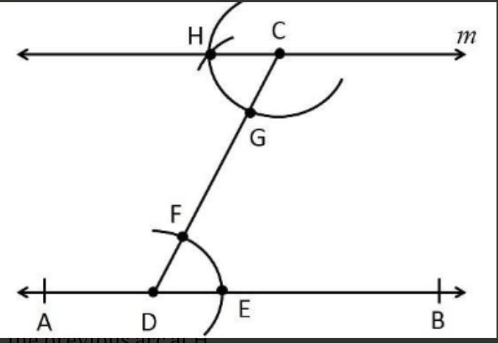

Fundamental Concept
# Source: AI Source: Provided by: [Data Path: Persons Table -> ID Column: 1, Name_En Column: Motasem Essam] -> From: [ChatGPT] on [7/25/2026]
A parallel line can be constructed by reproducing an angle made by the given line with another line.
If a transversal intersects two lines and the corresponding angles are equal, the two lines are parallel.
Thus, one classical construction is based on:
$$\boxed{\text{Copying an angle}}$$
The copied angle creates a line through the given point that has the same direction as the original line.
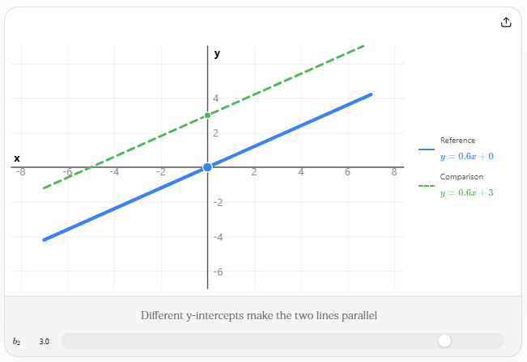

Main Construction
# Source: AI Source: Provided by: [Data Path: Persons Table -> ID Column: 1, Name_En Column: Motasem Essam] -> From: [ChatGPT] on [7/25/2026]
Suppose we are given:
- a line $l$
- a point $P$outside $l$
We want to construct a line $m$through $P$such that:
$$m∥l$$

Construction Using an Angle Copy
- Draw a line from $P$to any point $A$on the given line $l$. This acts as a transversal.
- With the compass centered at $A$, draw an arc crossing $l$and $AP$.
- Without changing the compass width, draw the same arc centered at $P$.
- Measure the distance between the two intersection points of the first arc.
- Transfer that distance to the corresponding points on the arc centered at $P$.
- Draw the new ray through $P$and the transferred point.
- The resulting line $m$is parallel to $l$.
Therefore:
$$\boxed{m∥l}$$
because the corresponding angles are congruent.

Another Construction: Using a Perpendicular
# Source: AI Source: Provided by: [Data Path: Persons Table -> ID Column: 1, Name_En Column: Motasem Essam] -> From: [ChatGPT] on [7/25/2026]
A parallel line can also be constructed by using two perpendicular constructions.
If:
$$m⊥n$$
and
$$l⊥n$$
then:
$$\boxed{m∥l}$$
Procedure
- Start with the given line $l$.
- Construct a perpendicular line $n$to $l$.
- Through the given point $P$, construct another line $m$perpendicular to $n$.
- Since both $l$and $m$are perpendicular to the same line $n$:
$$\boxed{m∥l}$$
This method connects the construction of parallel lines with the construction of perpendicular lines.
Basic Structure
Given:
$$P∉l$$
Construct:
$$m∋P$$
such that:
$$m∥l$$
The completed configuration is:
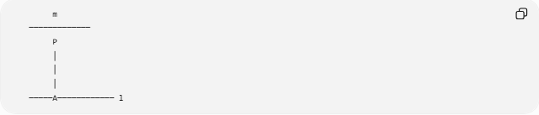
m
─────────────
P
│
│
│
─────A──────────── l
Here:
- $l$= given line
- $P$= given point
- $m$= constructed parallel line
- $A$= point on the given line used during construction

Mathematical Properties
# Source: AI Source: Provided by: [Data Path: Persons Table -> ID Column: 1, Name_En Column: Motasem Essam] -> From: [ChatGPT] on [7/25/2026]
1. Parallel Lines Do Not Intersect
For distinct parallel lines:
$$\boxed{l∥m}$$
they have no common point.
2. Parallel Lines Have the Same Direction
In coordinate geometry, non-vertical parallel lines have equal slopes:
$$\boxed{m_{1}=m_{2}}$$
For example:
$$y=2x+1$$
and
$$y=2x-4$$
are parallel because both have slope:
$$m=2$$
3. Corresponding Angles Are Equal
If a transversal crosses parallel lines:
$$\boxed{\text{Corresponding angles are congruent}}$$
4. Alternate Interior Angles Are Equal
For parallel lines:
$$\boxed{\text{Alternate interior angles are congruent}}$$
5. Consecutive Interior Angles Are Supplementary
$$\boxed{α+β={180}^{∘}}$$

Types of Constructing Parallel Lines
# Source: AI Source: Provided by: [Data Path: Persons Table -> ID Column: 1, Name_En Column: Motasem Essam] -> From: [ChatGPT] on [7/25/2026]
The main construction situations can be organized as follows:
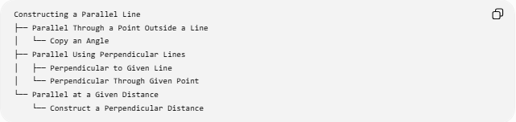
Constructing a Parallel Line
├── Parallel Through a Point Outside a Line
│ └── Copy an Angle
├── Parallel Using Perpendicular Lines
│ ├── Perpendicular to Given Line
│ └── Perpendicular Through Given Point
└── Parallel at a Given Distance
└── Construct a Perpendicular Distance

1. Parallel Through a Point Outside a Line
# Source: AI Source: Provided by: [Data Path: Persons Table -> ID Column: 1, Name_En Column: Motasem Essam] -> From: [ChatGPT] on [7/25/2026]
This is the fundamental classical construction.
Given:
$$P∉l$$
Construct:
$$m∋P, m∥l$$

2. Parallel Using Perpendicular Lines
# Source: AI Source: Provided by: [Data Path: Persons Table -> ID Column: 1, Name_En Column: Motasem Essam] -> From: [ChatGPT] on [7/25/2026]
Construct two lines perpendicular to the same line:
$$m⊥n, l⊥n$$
Therefore:
$$\boxed{m∥l}$$

3. Parallel at a Given Distance
# Source: AI Source: Provided by: [Data Path: Persons Table -> ID Column: 1, Name_En Column: Motasem Essam] -> From: [ChatGPT] on [7/25/2026]
Sometimes the required parallel line must also be a specified distance $d$from the original line.
The distance between parallel lines is constant:
$$\boxed{d\left(l , m\right)=d}$$
A perpendicular segment between the lines represents their shortest distance.

Construction Tools
# Source: AI Source: Provided by: [Data Path: Persons Table -> ID Column: 1, Name_En Column: Motasem Essam] -> From: [ChatGPT] on [7/25/2026]
Classical Euclidean construction uses:
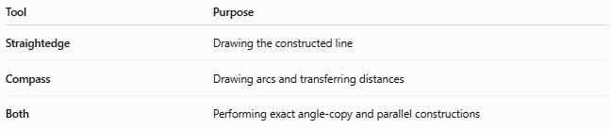
Tool | Purpose
Straightedge | Drawing the constructed line
Compass | Drawing arcs and transferring distances
Both | Performing exact angle-copy and parallel constructions

Parallel Line vs Perpendicular Line
# Source: AI Source: Provided by: [Data Path: Persons Table -> ID Column: 1, Name_En Column: Motasem Essam] -> From: [ChatGPT] on [7/25/2026]
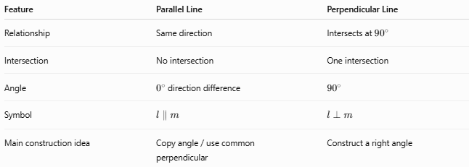
Feature | Parallel Line | Perpendicular Line
Relationship | Same direction | Intersects at ${90}^{∘}$
Intersection | No intersection | One intersection
Angle | $0^{∘}$direction difference | $${90}^{∘}$$
Symbol | $$l∥m$$ | $$l⊥m$$
Main construction idea | Copy angle / use common perpendicular | Construct a right angle

Parallel Line vs Perpendicular Bisector
# Source: AI Source: Provided by: [Data Path: Persons Table -> ID Column: 1, Name_En Column: Motasem Essam] -> From: [ChatGPT] on [7/25/2026]
These are different constructions.
Parallel line:
$$m∥l$$
It does not necessarily pass through the midpoint of anything.
Perpendicular bisector:
$$PM⊥AB$$
and:
$$AM=MB$$
Therefore, a perpendicular bisector has two requirements: it must be perpendicular to the segment and pass through its midpoint.

Important Relationship
# Source: AI Source: Provided by: [Data Path: Persons Table -> ID Column: 1, Name_En Column: Motasem Essam] -> From: [ChatGPT] on [7/25/2026]
The construction of parallel lines is closely related to other basic constructions:
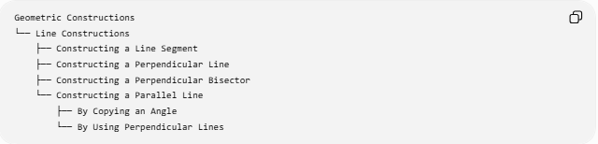
Geometric Constructions
└── Line Constructions
├── Constructing a Line Segment
├── Constructing a Perpendicular Line
├── Constructing a Perpendicular Bisector
└── Constructing a Parallel Line
├── By Copying an Angle
└── By Using Perpendicular Lines

Key Formula and Conditions
# Source: AI Source: Provided by: [Data Path: Persons Table -> ID Column: 1, Name_En Column: Motasem Essam] -> From: [ChatGPT] on [7/25/2026]
For two non-vertical lines:
$$\boxed{m_{1}=m_{2}}$$
For a line and its perpendicular:
$$\boxed{m_{1}m_{2}=-1}$$
Therefore, if two lines are both perpendicular to the same line, they are parallel:
$$\boxed{l⊥n, m⊥n⇒l∥m}$$

Classification Summary
# Source: AI Source: Provided by: [Data Path: Persons Table -> ID Column: 1, Name_En Column: Motasem Essam] -> From: [ChatGPT] on [7/25/2026]
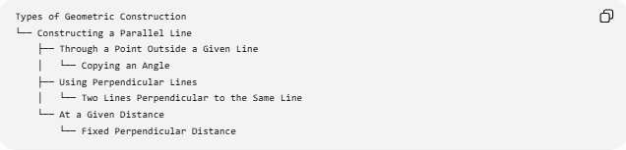
Types of Geometric Construction
└── Constructing a Parallel Line
├── Through a Point Outside a Given Line
│ └── Copying an Angle
├── Using Perpendicular Lines
│ └── Two Lines Perpendicular to the Same Line
└── At a Given Distance
└── Fixed Perpendicular Distance

Key Points
# Source: AI Source: Provided by: [Data Path: Persons Table -> ID Column: 1, Name_En Column: Motasem Essam] -> From: [ChatGPT] on [7/25/2026]
- A parallel-line construction creates a line through a given point that does not intersect the given line.
- The fundamental condition is:
$$\boxed{m∥l}$$
- A classical construction can be performed by copying an angle.
- Another method uses two perpendicular lines.
- Parallel lines have the same direction.
- Non-vertical parallel lines have equal slopes.
- Corresponding and alternate interior angles are equal when a transversal intersects parallel lines.
- Consecutive interior angles are supplementary.
- A perpendicular line forms a ${90}^{∘}$angle, while a parallel line has the same direction as the given line.

Conclusion
# Source: AI Source: Provided by: [Data Path: Persons Table -> ID Column: 1, Name_En Column: Motasem Essam] -> From: [ChatGPT] on [7/25/2026]
Constructing a Parallel Line is a fundamental Euclidean geometric construction used to create a line through a specified point that is parallel to a given line. It can be achieved classically by copying an angle or by constructing two lines perpendicular to the same line. The construction is based on the geometric properties of parallel lines, equal corresponding angles, and common perpendiculars.

